Second Quarter
Study Guide
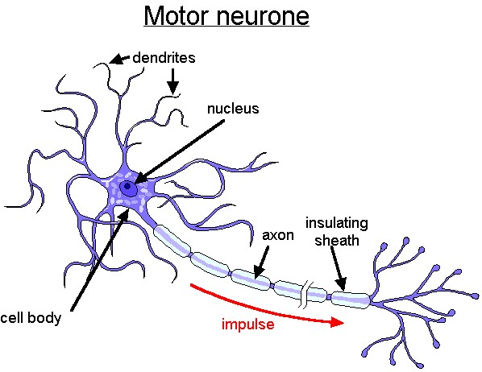

- What is the function of skeletal system?

- What is the function of the nervous system?

- Describe fight or flight and the system that it belongs to.
.
- What is the function of the reproductive system?

- How is homeostasis maintained by the integumentary system?

- What is the function of the muscular system?

- What are the three statements of cell theory?

- What is the function of the endocrine system?

- What are the differences in organic and inorganic?
- What is the function of the excretory system?

- What is the path of urine through the body?

- What is the function of the integumentary system?

- What is the function of the digestive system?

- Describe where and how physical and chemical digestion occurs.
- What is the function of the respiratory system? Place the following in order 1-6

Trachea Nose and Mouth Bronchi Alveoli Lungs bronchioles

- What is the function of the circulatory system?

- What are the organelles that provide energy for the cells activities?

- What system uses the most energy?

- What are the functional units of the body? List from smallest to largest. Give examples.

- What is an independent variable?

- What is a dependent variable?

- Identify the nerve cell, blood cell and muscle cell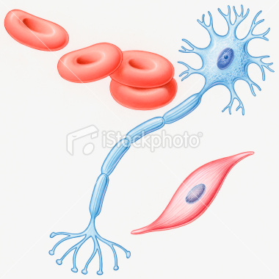

- What is a constant in an experiment?

- If a desk was 2 meters wide and 3 meters in length, how many could fit in a room that was 13 meters wide?

- Diagram and label the digestive system.

- Where is the genetic material located in a eukaryotic cell?

- Describe the energy transformation in how the body is moved

- What is the difference in a molecule and an atom?

- .Create Venn diagrams to compare the following body systems

Excretory and Digestive

Integumentary and Excretory

Immune and Integumentary

