Name: ________________________ Date: ____________ Pd: ___
REVIEW – QCA 1 – 2016-2017
- VOCABULARY (Define the following terms.)
- experimental design -

- hypothesis -
- independent variable -

- dependent variable -

- constants -

- experimental group -

- control group -

- fertilizer -

- work -

- force -

- Newton (N) -

- NFPA diamond -

  - Flammability -
  - Reactivity -
  - Specific Hazards -
  - Health -
- triple beam balance -

- grams (g) -

- meter (m) -
- pounds (lbs) -

- plant cell -

- animal cell -

- organelle -

- lysosome -

- vacuole -

- cytoplasm -
- mithochondria -

- cellular respiration -

- ribosomes -

- cell membrane -

- cell wall -

- chloroplast -

- chlorophyll -

- photosynthesis -

- cell -

- nucleus -

- chromosome -

- DNA -

- gene -

- inherited traits -
- genetic disorder -

- offspring -

- microscope -

- objective lens -

- scanning objective lens -

- low power objective lens -

- high power objective lens -

- total magnification -

- field of view -

- quantitative data -
- qualitative data -

- safety goggles -

- density -

- mass -
- volume -

- water displacement method -

- graduated cylinder -

II. QUESTIONS - Answer the questions below.

- What is the formula for finding density?

- What is the density of a substance when the mass is 500 grams and the volume is 250 ml? Show your work!
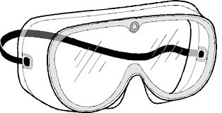
- When should you use safety goggles in the lab?

- Identify whether each statement below is Qualitative Data or Quantitative Data.
Underline or highlight the word(s) in each statment that helped you identify these types of data.
- ___________________ The gummy worm increased by 2 inches.
- ___________________ Gas formation was present in the experiment.
- ___________________ A thermal reaction occurred.
- ___________________ The patient had a temperature 102⁰ F.
- ___________________ The solution changed from blue to yellow.
- ___________________ The sample with the baking soda appeared bubbly.

5. Give two examples of qualitative data and two examples of quantitative data that could be obtained from the image to the right.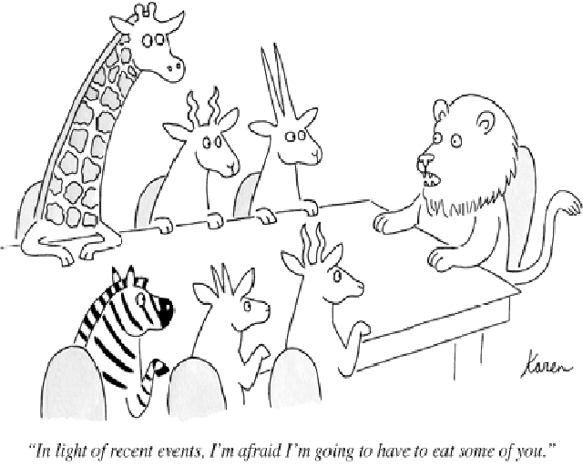

Qualitative Data:
- ______________________________
- ______________________________

6. Quantitative Data:
- ______________________________
- ______________________________
7. State the three parts to the cell theory.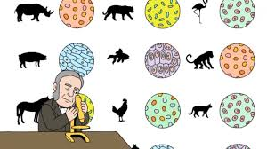

- ___________________________________________
- ___________________________________________
- ___________________________________________

8. Identify the 5 levels of organization in plants and animals starting with the smallest:
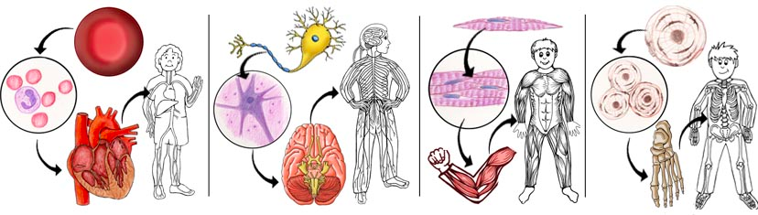
- ___________________________
- ___________________________
- ___________________________
- ___________________________
- organism

8. In order for work to occur, you must apply a force (N) x distance. If distance is not applied, then work is not occurring. What could be done in the diagram below to illustrate work being done?
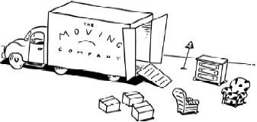
9. Explain how an inclined plane would help in moving the sofa onto a truck?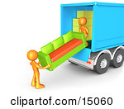

10. How much work is being done in the examples below? Show your work by using the formula (Work = Force X Distance).
- A person uses 50 N of force to lift a box 10 meters in the air.

- A person uses 100 N of force to hold an object in the air without moving the object.

11. How could the person in the diagram below reduce the amount of force needed to push the box up the ramp (inclined plane)? Explain and illustrate your answer.
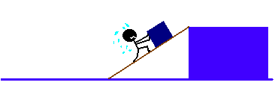
12. The NFPA diamond is deisigned to give general hazard information for chemicals. Color each section with the appropriate color and identify what each section of the diamond represents. (Flammability, Reactivity, Specific Hazards, Health)
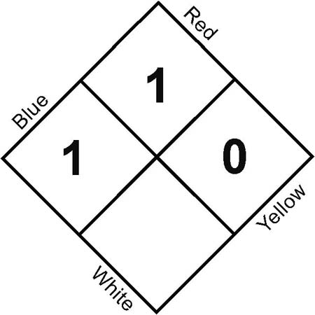
12. What is a triple beam balance used for? ___________________________________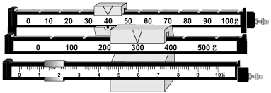
13. What is the reading on the triple beam balance to the right? Be sure to include unit of measurement.
____________________

14. What is a graduated cylinder used for? ___________________________________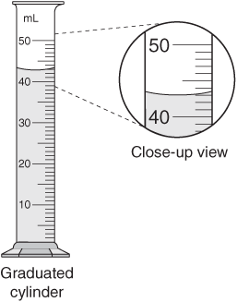
15. What is the reading on the graduated cylinder shown? Be sure to include unit of measurement.
____________________

15. Draw, label and color the organelles found within a plant cell and animal cell. Describe the function of each organelle.
Plant Cell Drawing | Animal Cell Drawing

Organelle | Function
nucleus
chromosomes
cell membrane
ribosomes
mitochondrion
cytoplasm
vacuole
cell wall
chloroplasts
chlorophyll

16. Complete the Venn Diagram below by identifying what organelles are found in both plant and animal cells and which are only found in each type of cell.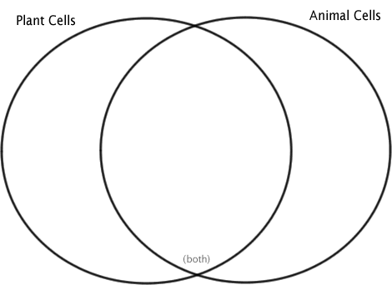

17. Find the volume of the object below by using the water displacement method.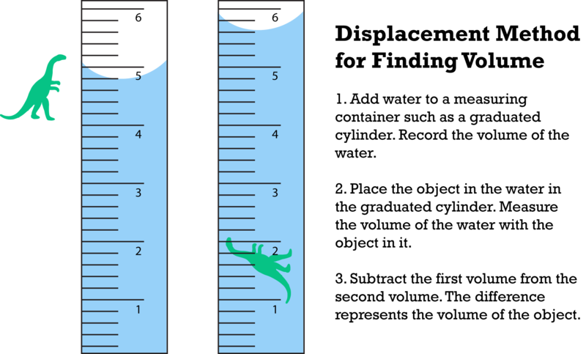
__________ Volume of water in graduated cylinder prior to object being placed in it.
__________ Volume of water in graduated cylinder with object placed in it.
__________ Volume of object.
18. Inherited traits are found in the genetic material of cells. Put the following levels of organization in the correct order from smallest to largest.
DNA – cell – chromosome – genes – nucleus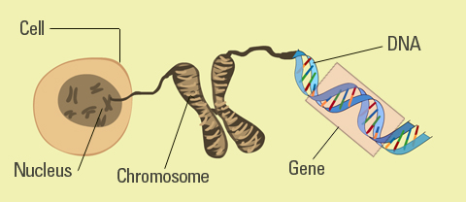
- (smallest) ________________
- _________________________
- _________________________
- _________________________
- (largest) __________________

19. Cell Analagoy: Compare the cell organelles to the parts of a house or school.
Cell Organelle | Parts of a house or school
nucleus
cell membrane
cell wall
mitochondrion
vacuole

20. A student is doing an experiment to see the effects of different amounts of fertilizer on the growth of plants. The student uses the same plant, the same soil, same size planter, gives the plants the same amount of light, gives them the same amount of water, & has them in the same location. Fill out the following IVCDV chart.
Independent Variable | Constants | Dependent Variable
21. Mr. Krabbs has created a new sauce that he thinks will reduce the production of body gas associated with eating crabby patties from the Krusty Krab. He recruits 100 customers with a history of gas problems. He has 50 of them (Group A) eat crabby patties with the new sauce. The other 50 (Group B) eat crabby patties with sauce that looks just like new sauce but is really just mixture of mayonnaise & food coloring. Both groups were told that they were getting the sauce that would reduce gas production. Two hours after eating the crabby patties, 30 customers in group A reported having fewer gas problems & 8 customers in group B reported having fewer gas problems.

- What is the independent variable?
- What is the dependent variable?
- What is the control group?
- What is the experimental group?

22. Read the following statement and identify the hypothesis, variables, control group, experimental group and constants.

Eating breakfast increases performance in school.

- Hypothesis: If _____________________________________________________, then _____________________________________________________________.
- Independent Variable: ______________________________________________.
- Dependent Variable: ________________________________________________.
- Control Group: ____________________________________________________.
- Experimental Group: ________________________________________________.
- Constants: ________________________________________________________.

23. Why is the wagon moving to the right?
______________________________________________________________________
______________________________________________________________________
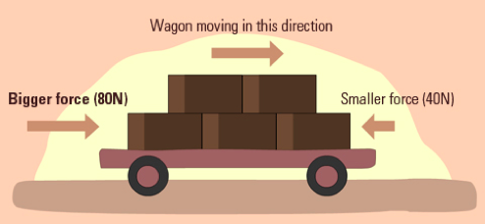

Use the graph below to answer #’s 24-26.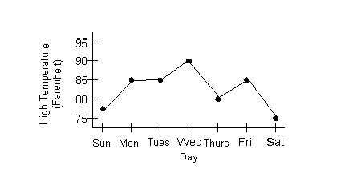

24. What would be an appropriate title for the line graph?
____________________________________________________________
25. What is the independent variable? __________________________________
26. What is the dependent variable? ___________________________________

