Body Systems Test Review
Name this system:
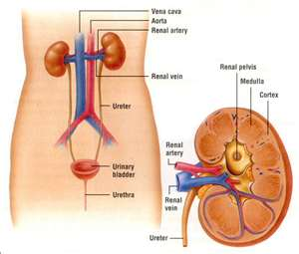
What are the important structures in this system?

What is the function of this system?

Name this system:
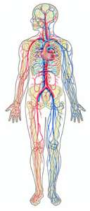
What are the important structures in this system?

What is the function of this system?

Name the system this belongs to:
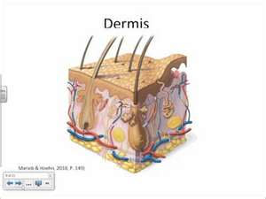
What are the important structures in this system?

What is the function of this system?

Name this system:
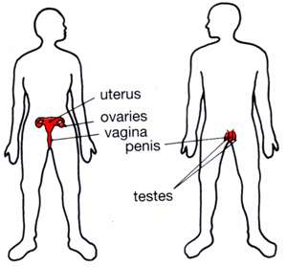
What are the important structures in this system?

What is the function of this system?

Name this system:
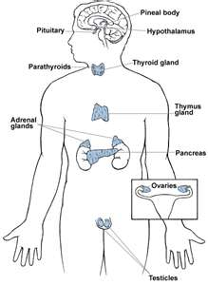
What are the important structures in this system?

What is the function of this system?

Name this system:
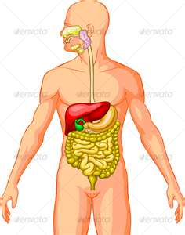
What are the important structures in this system?

What is the function of this system?

Name this system:
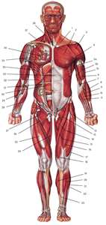
What are the important structures in this system?

What is the function of this system?

Name this system:
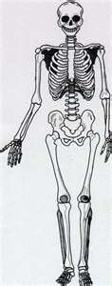
What are the important structures in this system?

What is the function of this system?

Name this system:
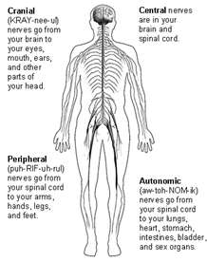
What are the important structures in this system?

What is the function of this system?
Define: Structure

Define: Function

Define: Homestasis

Draw and give the function: Skeletal Muscle

Draw and give the function: Smooth Muscle Tissue

Draw and give the function: Cardiac Muscle Tissue

Draw and give the function: The Nerve Cell Tissue

Give the function of bones:

Give the function of bone marrow:

Give the function of blood:

Give the function of hormones:

Give the function of the immune system:

Give an example of a cell, organ, tissue, organ system, and organism

What function does a cell play in a body system?

Give an example of how each cell structure plays a part in one or more body systems
Cell Membrane
Ribosome
Mitochondria
Nucleus
Vacuole

Give an example of a physical and chemical change in one or more body systems.
Physical Change
Chemical Change

Give an example of how two or more body systems work together to complete a task

